BIT3208: ADVANCED WEB DESIGN AND DEVELOPMENT
Student details
Student Name: Wendy Jane
Admission Number: BSCCS/35574/2024
Course: Computer Science
Unit Code: BIT3208
Unit Name: Advanced Web Design and Development
Lecturer Name: Mr. Michael Nyoro
Semester/Academic Year: 2025/2026
Project details
Project Title: Smart E-Commerce System
Selected Technologies: PHP + MySQL
GitHub link
https://github.com/wjane8346/smart-ecommerce

Table of Contents
Week 1: Local Environment Setup 5
Installation of XAMPP 5
6
Apache and MySQL Running 7
Localhost Test Page 8
Hello World Test 8
Database Connection Test 9
Student Reflection 9
Week 2: Wireframes and GUI Design 10
Hand-drawn Wireframe 10
Dashboard Layout Design 11
Mobile View Mockup 12
Color Theme and Navigation Structure 13
GUI Prototype in Draw.io 14
14
Student reflection 15
Week 3: JavaScript and PHP Basics 16
JavaScript Form Validation 16
16
Password Strength Checker 17
17
PHP Syntax Practice 18
Database Connection Script 19
Dynamic User Input Handling 20
Week 4: Server-Side Components and Backend Development Foundations 21
Understanding Server-Side Programming 21
HTML Forms and PHP Integration 21
Simple Authentication System 23
Backend Folder Organization 24
Week 5: Database Components and CRUD Operations 25
Database Creation 25
Creating Tables 26
CRUD Operations 28
Connecting PHP to Database 30
Fetching Database Records 30
Student reflection 31

Week 1: Local Environment Setup

Installation of XAMPP

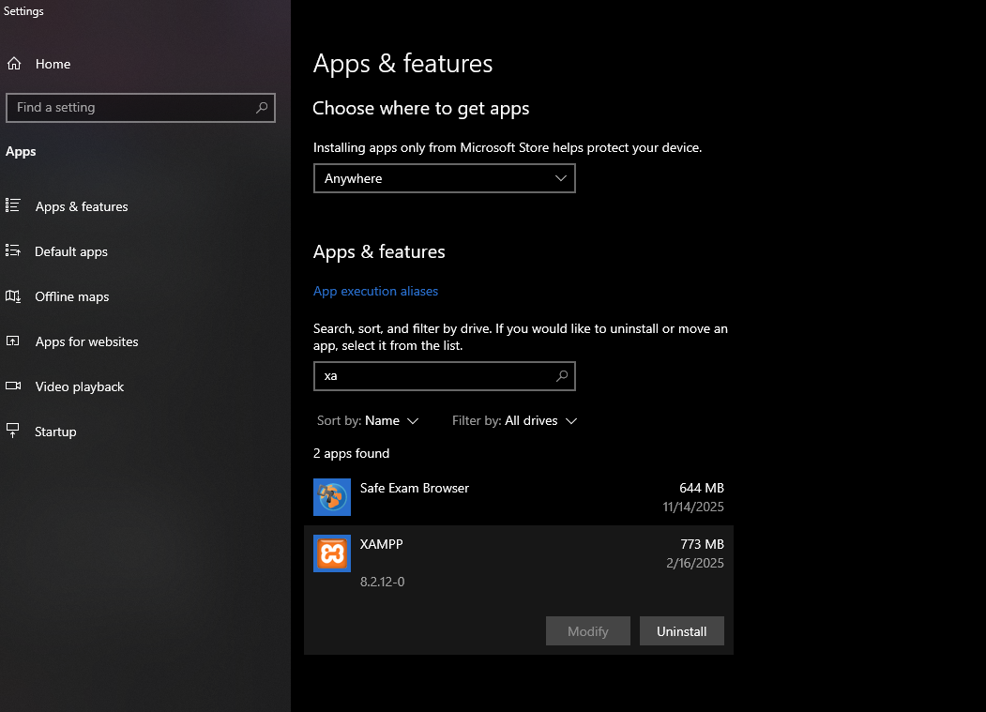

Fig 1 shows XAMPP Control Panel about dialog confirming XAMPP version 8.2.12 is installed and operational on the system.

Apache and MySQL Running
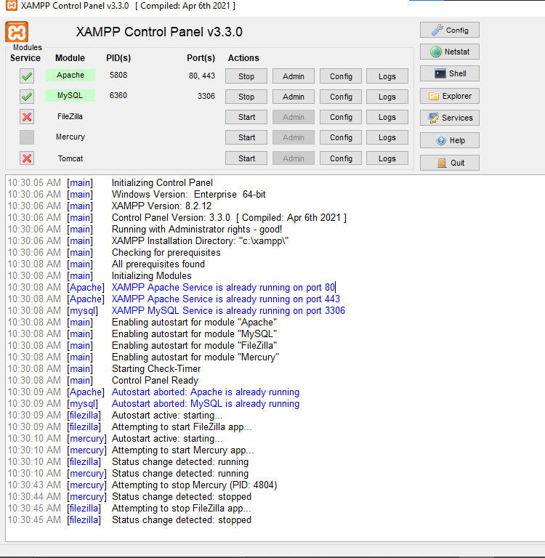
Fig 2 displays the XAMPP Control Panel with both Apache (Port 80) and MySQL (Port 3306) services running successfully, indicated by the green highlighting.

Localhost Test Page
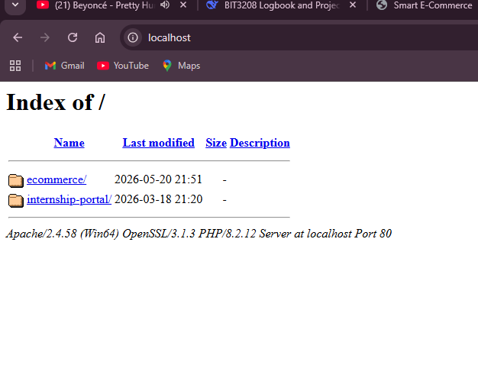
Fig 3 demonstrates localhost running successfully at http://localhost, displaying the directory listing of htdocs which confirms Apache is properly configured.

Hello World Test
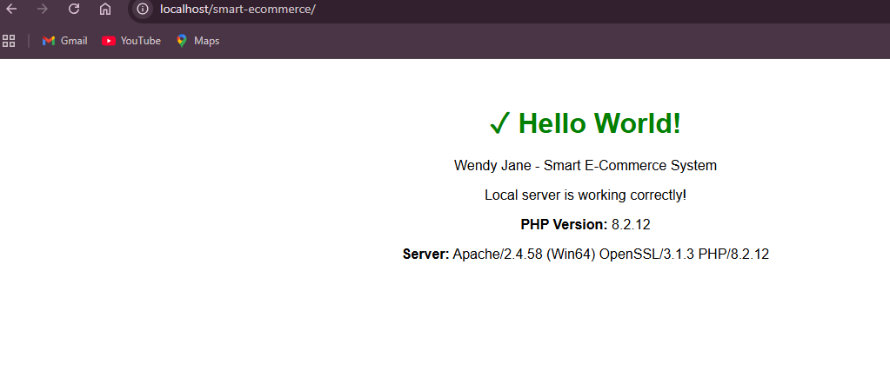
Fig 4 shows my Hello World test page at http://localhost/smart-ecommerce/ which successfully executes both HTML and PHP code, confirming PHP integration with Apache.

Database Connection Test
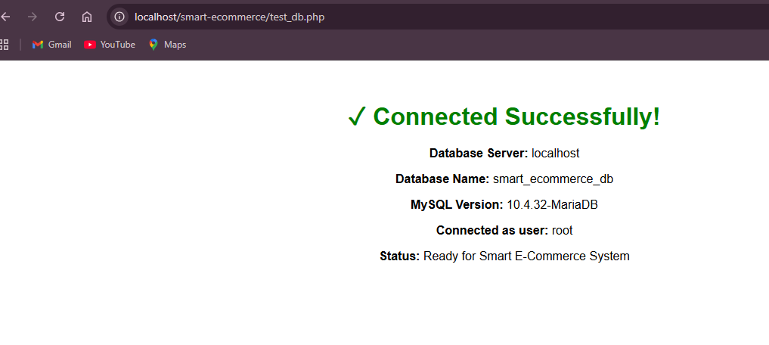
Fig 5 confirms successful MySQL database connection using mysql_connect(). The connection to smart_ecommerce_db on localhost using root user was verified, showing MySQL server version and ready status for database operations.

Student Reflection
This week the existing XAMPP local development environment was verified for the Smart E-Commerce System. Apache and MySQL work together as a local web server with PHP processing was learned. The main challenge was ensuring all project files are placed correctly in the htdocs folder to be accessible via the browser. The screenshots demonstrate:1 shows XAMPP installation verified, Fig 2 confirms Apache and MySQL running, Fig 3 verifies localhost access, Fig 4 proves PHP execution with Hello World, and Fig 5 validates database connectivity to smart_ecommerce_db. Technologies used include XAMPP, Apache, MySQL,php and phpMyAdmin.

Week 2: Wireframes and GUI Design

Hand-drawn Wireframe
‘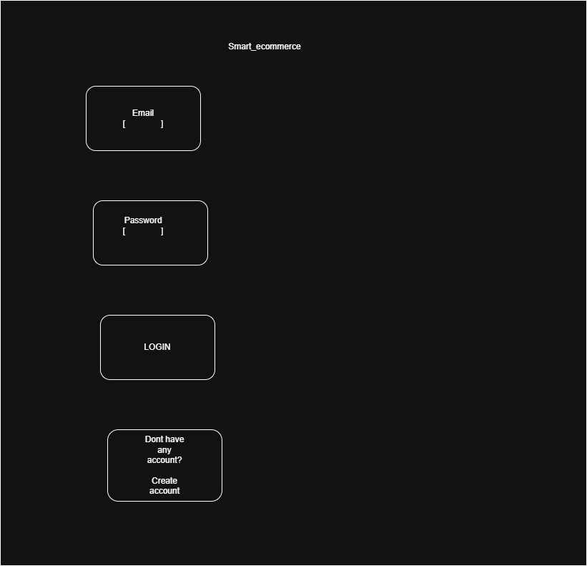
Fig 1 shows the login page wireframe created in Draw.io for the Smart E-Commerce System. The design includes email field, password field, login button, and registration link.

Dashboard Layout Design
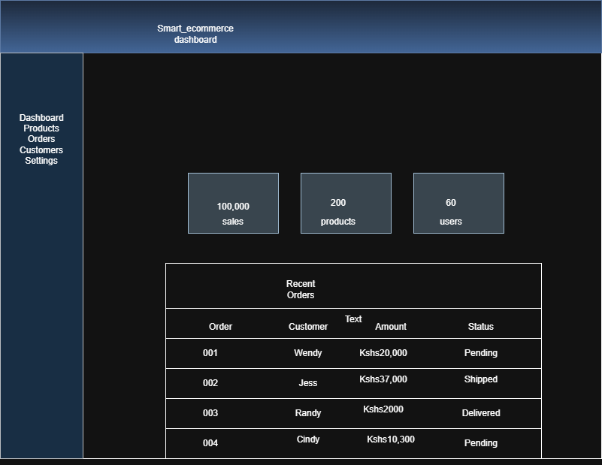
Fig 2 displays the dashboard layout for the Smart E-Commerce admin panel. The design includes a left sidebar navigation menu, top header with user profile, and main content area with statistics cards and recent orders table.

Mobile View Mockup
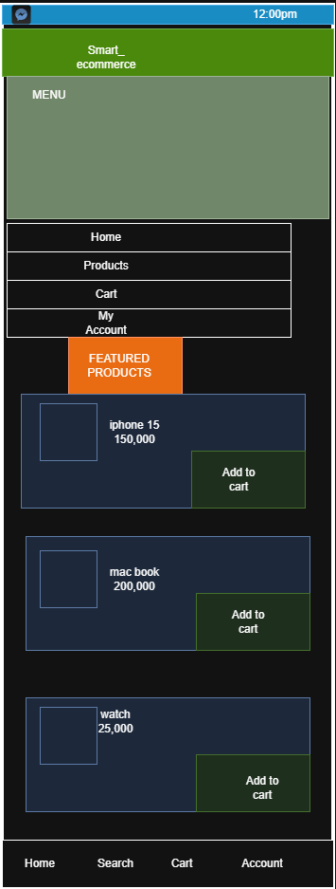
*Fig 3 presents the mobile responsive mockup for the Smart E-Commerce System created in Draw.io. The design features a phone-sized frame (350×600), status bar, collapsed sidebar menu with navigation links (Home, Products, Cart, Account), featured products section with three product cards (iPhone 15, MacBook , watch), and bottom navigation bar. This layout ensures full usability on smartphone screens (width less than 768px)

Color Theme and Navigation Structure
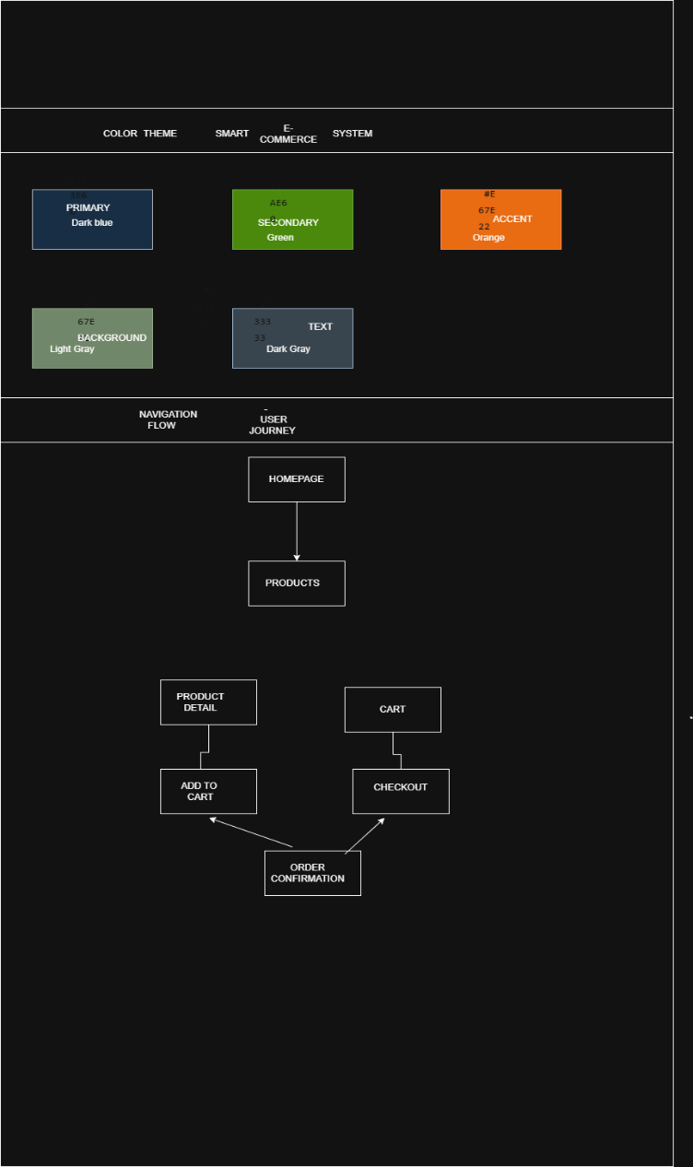
Fig 4 illustrates the color theme and navigation structure for the Smart E-Commerce System. The color theme consists of five colors: Primary (#2C3E66 - dark blue for headers and buttons), Secondary (#27AE60 - green for success messages and add to cart buttons), Accent (#E67E22 - orange for warnings and promotions), Background (#F5F5F5 - light gray for page backgrounds), and Text (#333333 - dark gray for body content).

GUI Prototype in Draw.io

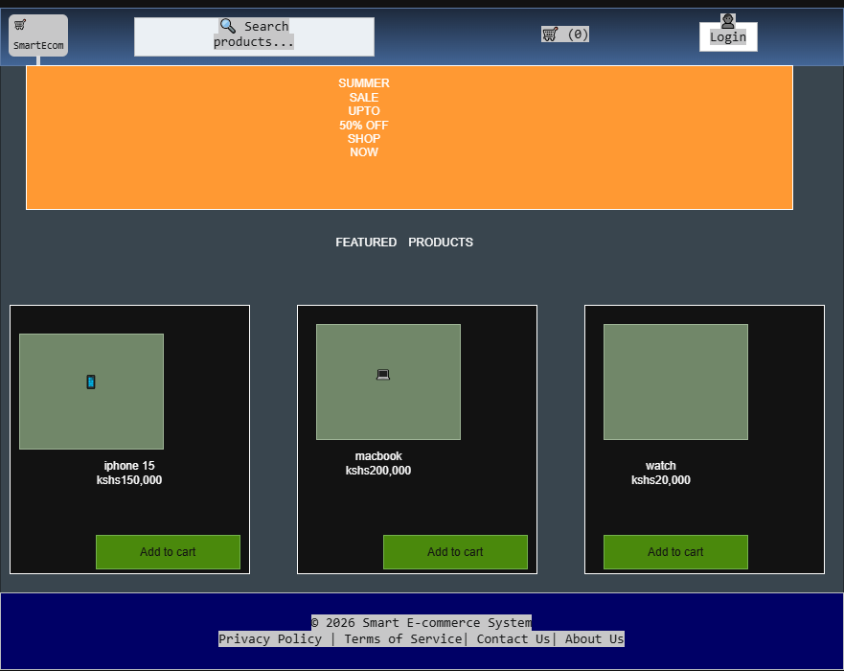
Fig 5 shows the complete GUI prototype for the Smart E-Commerce System created in Draw.io. The design includes a dark blue header with logo, search bar, cart icon, and login link. An orange hero banner promotes a summer sale with 50% off. The featured products section displays three product cards (iPhone 14, MacBook Air, AirPods Pro) each containing a product image, name, price, and green add to cart button. A dark blue footer contains copyright information and navigation links. This prototype represents the visual layout before coding begins.

Student reflection
The clean e-commerce design was selected for the Smart E-Commerce System to prioritize product visibility and ease of purchase. User experience considerations included minimal clicks to checkout, clear call-to-action buttons, and responsive layouts for all screen sizes. The navigation flow was planned as a logical path: homepage → products→ cart → checkout → confirmation, matching successful e-commerce platforms. The left sidebar admin dashboard enables scalable module management for future system growth. Intended system users are online shoppers and store administrators. Draw.io served as the primary design tool for wireframes, mockups, and prototypes. Key design decisions focused on accessibility, reduced user friction, and mobile-first responsiveness.

Week 3: JavaScript and PHP Basics

JavaScript Form Validation

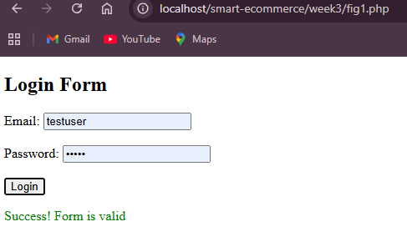
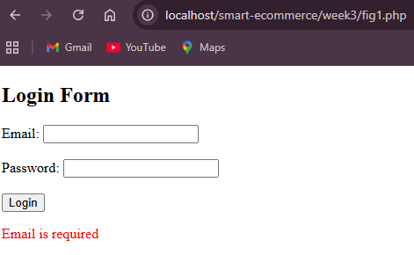
Fig 1 shows JavaScript form validation for the login page. The validation checks for empty email, empty password, and password length (minimum 4 characters). Error messages appear in red when validation fails, and a green success message appears when all fields are valid.

Password Strength Checker

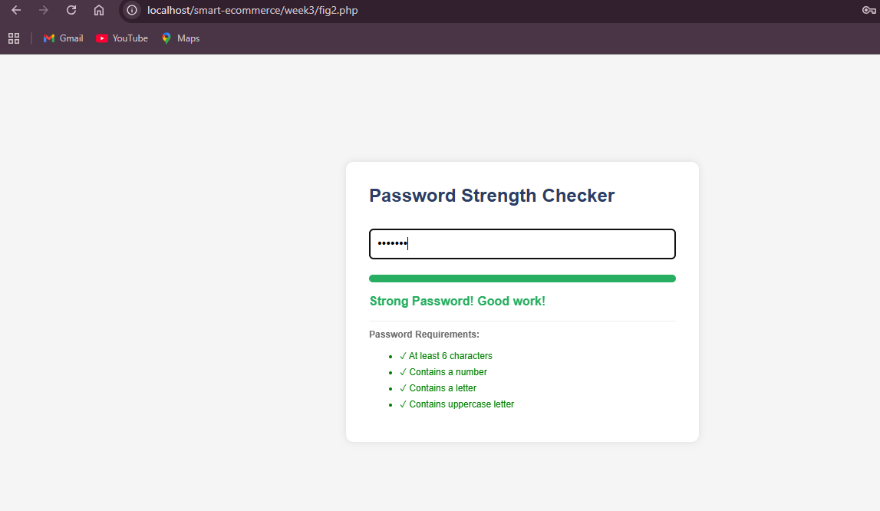
Fig 2 demonstrates a password strength checker that evaluates passwords in real-time as the user types. The checker analyzes length (minimum 6 characters), presence of numbers, letters, and uppercase characters. The strength meter displays weak (orange 33%), medium (yellow 66%), or strong (green 100%) with corresponding text feedback and checklist of requirements, helping users create secure passwords

PHP Syntax Practice
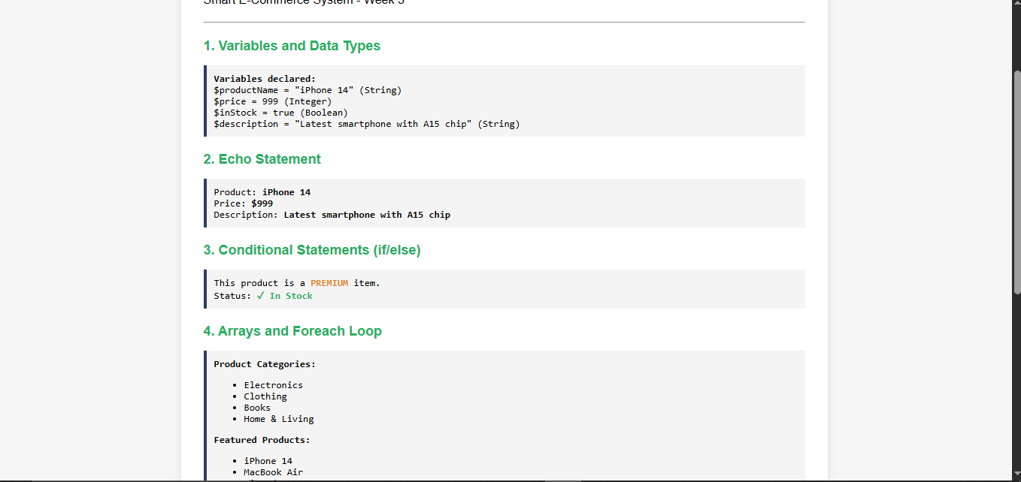
Fig 3 demonstrates PHP syntax including variables ($productName,$price), conditional statements (if/else), arrays with foreach and for loops, user-defined functions (calculateDiscount, applyTax), and string operations (strlen, strtoupper, strtolower). The page outputs product information, category listings, discounted price calculations, and string manipulations, proving PHP is properly configured on the local server for the Smart E-Commerce System.

Database Connection Script
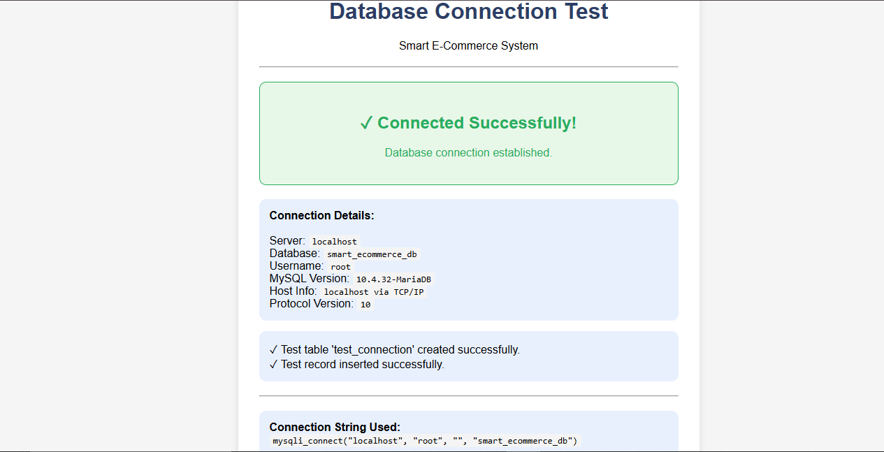
Fig 4 shows successful database connection using PHP mysql_connect(). The connection parameters include localhost as server, root as username, empty password, and smart_ecommerce_db as database name. The script outputs MySQL server version, host information, and successfully creates a test table with a sample record, confirming proper integration between PHP and MySQL for the Smart E-Commerce System.

Dynamic User Input Handling
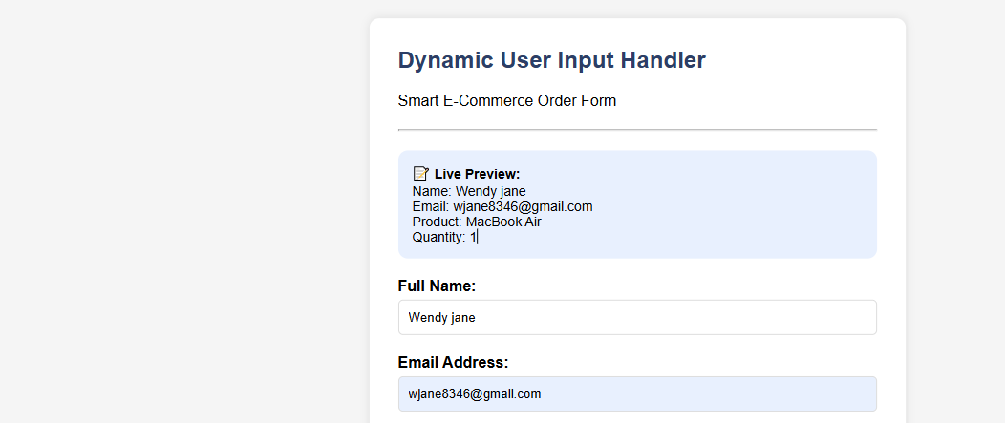
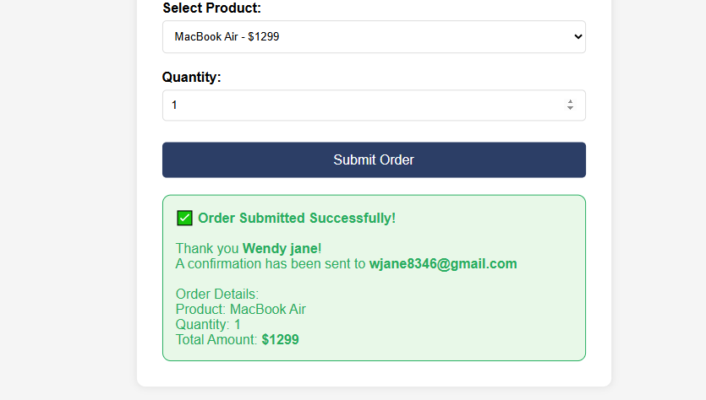
Fig 5 demonstrates dynamic user input handling with frontend JavaScript and backend PHP integration. JavaScript provides real-time live preview as the user types and validates form fields (name, email, product selection, quantity) before submission. The validation checks for empty fields, valid email format (must contain @ and .), and minimum quantity of 1. Upon successful validation, a success message displays the order summary including product, quantity, and total calculated price. PHP backend processing is in place to receive and log the data for database storage, proving the interaction between frontend and backend for the Smart E-Commerce System.

Week 4: Server-Side Components and Backend Development Foundations

Understanding Server-Side Programming
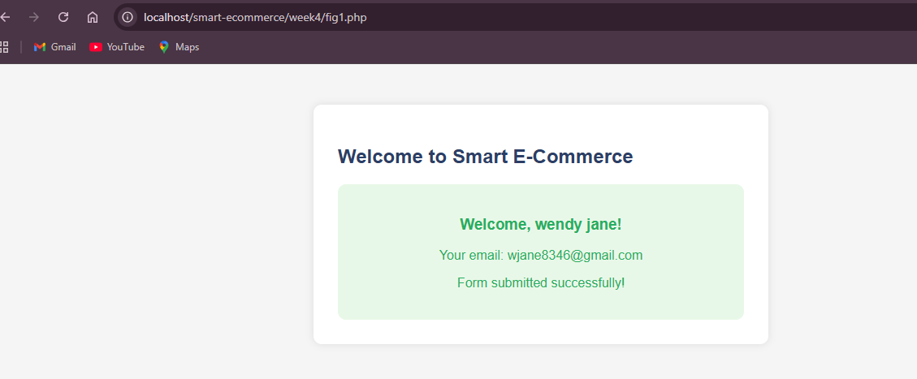
Fig 1 shows a simple PHP form processing page for the Smart E-Commerce System. The form accepts user name and email via POST method. When submitted, the PHP script processes the data and displays a welcome message with the submitted information. This demonstrates the request-response cycle where the browser sends form data to the server and the server returns dynamic content based on the input. The POST method is used to securely send data to the server.

HTML Forms and PHP Integration
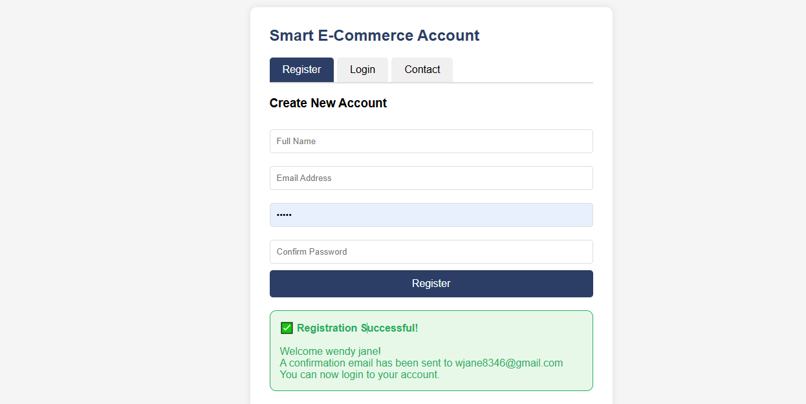
Fig 2a shows the registration form for the Smart E-Commerce System. The form collects full name, email address, password, and password confirmation. Validation checks include required fields, valid email format (must contain @ and .), password minimum length of 4 characters, and password matching. Upon successful validation, a success message confirms registration and indicates a confirmation email would be sent to the user.

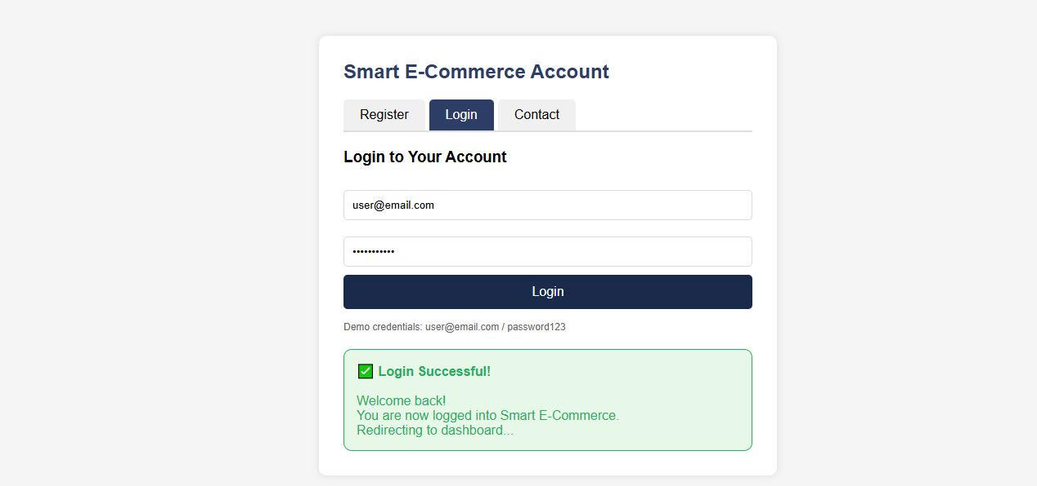
Fig 2b shows the login form for the Smart E-Commerce System. The form accepts email address and password. Validation checks for empty fields and verifies credentials against stored demo credentials (user@email.com / password123). Upon successful login, a welcome message appears. The POST method securely sends data to the server for authentication.

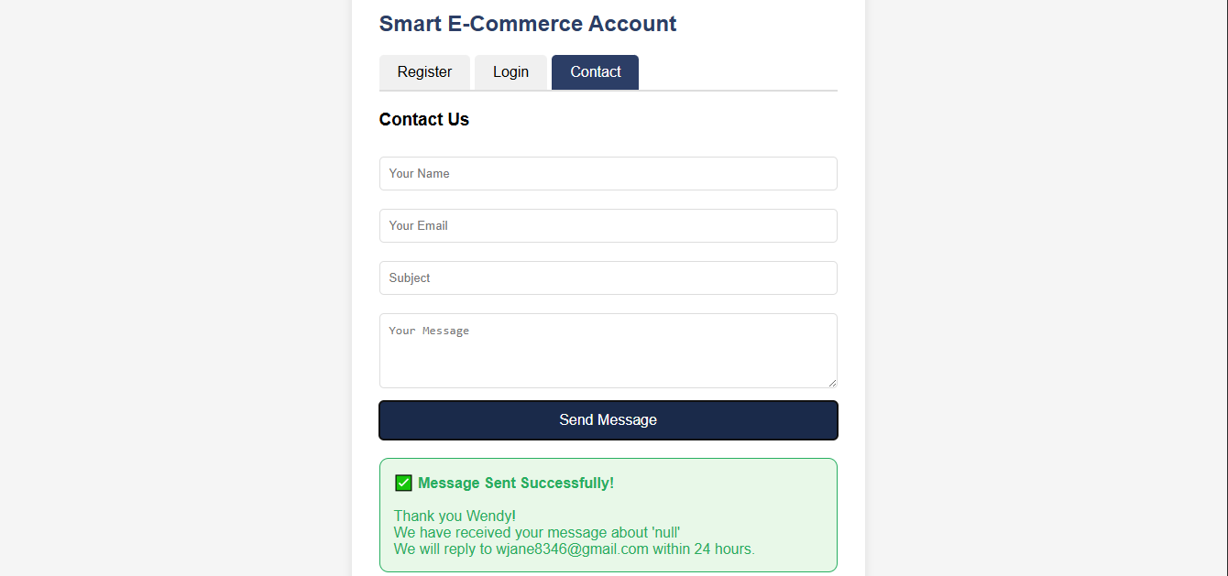
Fig 2c shows the contact form for the Smart E-Commerce System. The form collects name, email, subject, and message. Validation checks ensure all fields are completed and email format is valid. Upon successful submission, a confirmation message appears thanking the user and stating a response will be sent within 24 hours. This demonstrates proper form handling with both frontend validation and backend processing capability.

Simple Authentication System
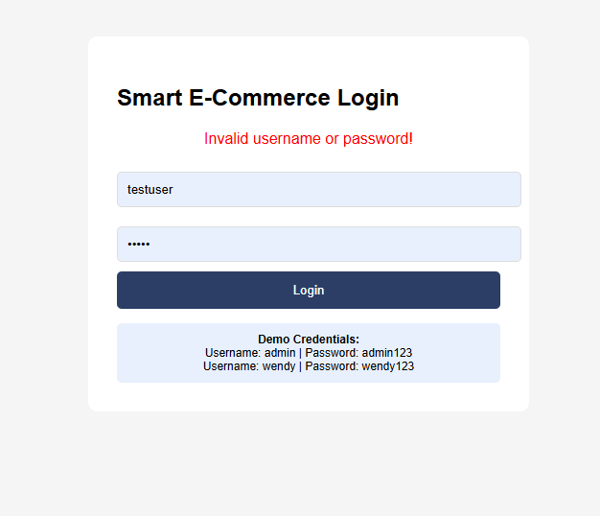
Fig 3a shows the login page with username/password validation. When invalid credentials are entered, an error message "Invalid username or password!" appears. The form uses POST method to send data. Valid credentials (admin/admin123 and wendy/wendy123) are hardcoded for demonstration. PHP conditionals check if submitted credentials match before granting access.
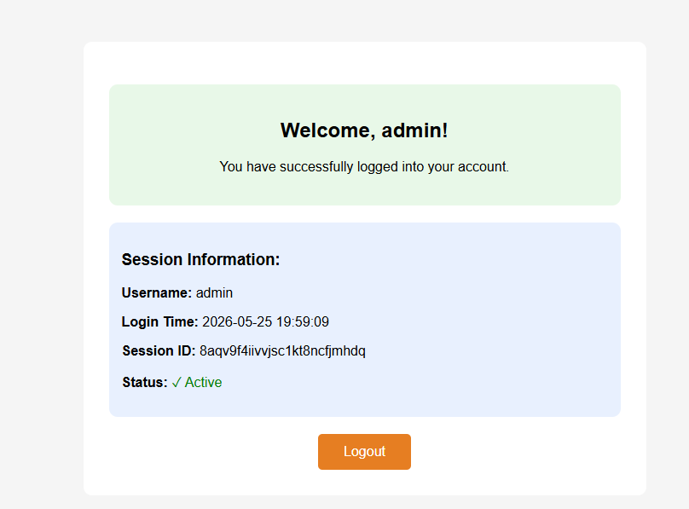
Fig 3b shows the session-based dashboard page after successful login. Session variables store username and login timestamp using ${}_{S}ESSION[^{'}user^{'}]and$_SESSION['login_time']. The dashboard displays a personalized welcome message, session ID, and login time. Session_start() maintains the session across pages. If a user tries to access the dashboard without logging in, they are automatically redirected to the login page.

Backend Folder Organization
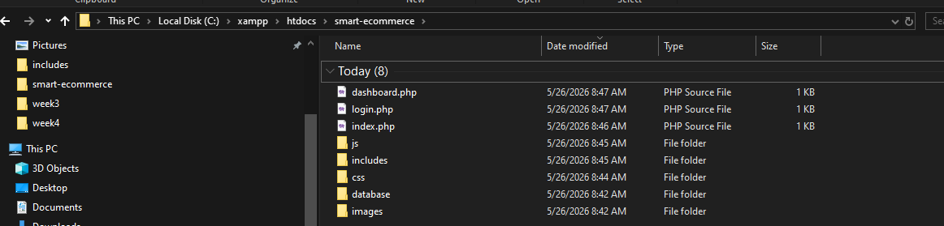
Fig 4 displays the professional folder structure for the Smart E-Commerce System. The structure includes index.php, login.php, and dashboard.php in the root directory. Subdirectories include css/ for stylesheets, js/ for JavaScript files, images/ for media assets, includes/ for reusable components (header.php, footer.php, db_connect.php), and database/ for SQL backups. This organization follows industry best practices for web application development.

Week 5: Database Components and CRUD Operations

Database Creation
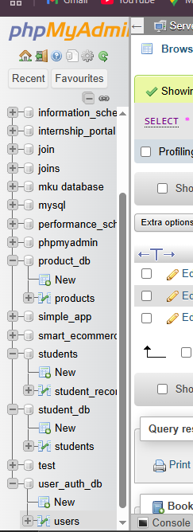
Fig 1 shows three databases created in phpMyAdmin for the Smart E-Commerce System: student_db for managing student records, product_db for product inventory management, and user_auth_db for user authentication and login credentials. Each database was created using the SQL command CREATE DATABASE. The left sidebar displays all databases including the existing smart_ecommerce_db. These databases will store different types of data for the complete system.

Creating Tables
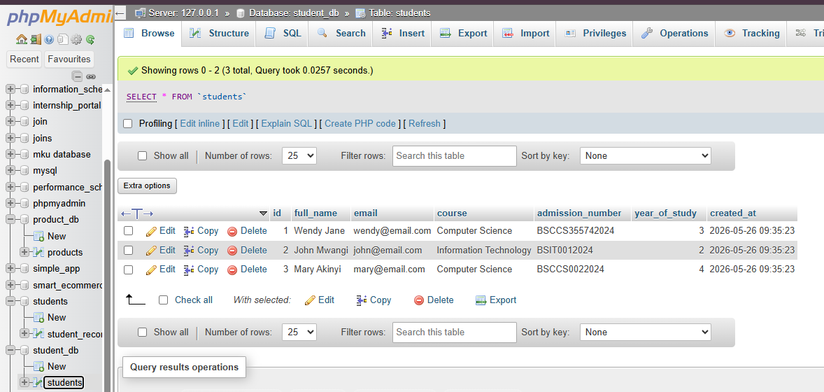
Fig 2a shows the students table created in student_db. The table includes columns: id (PRIMARY KEY AUTO_INCREMENT), full_name, email (UNIQUE), course, admission_number (UNIQUE), year_of_study, and created_at. Sample student records have been inserted.
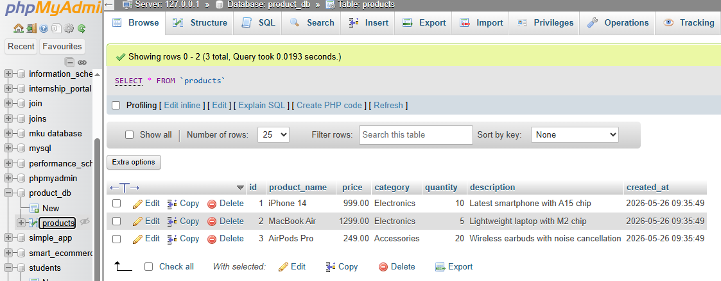
Fig 2b shows the products table created in product_db. The table includes columns: id (PRIMARY KEY AUTO_INCREMENT), product_name, price, category, quantity, description, and created_at. Sample product records (iPhone 14, MacBook Air, AirPods Pro) have been inserted.

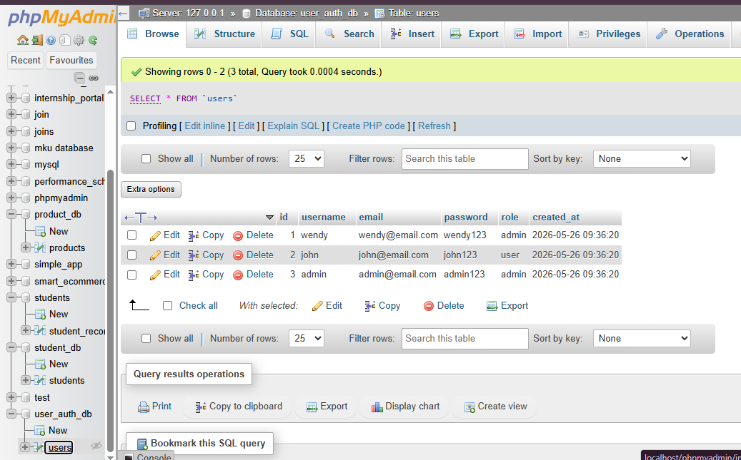

Fig 2c shows the users table created in user_auth_db. The table includes columns: id (PRIMARY KEY AUTO_INCREMENT), username (UNIQUE), email (UNIQUE), password, role, and created_at. Sample users (admin, wendy, john) with different roles have been inserted for authentication testing.

CRUD Operations
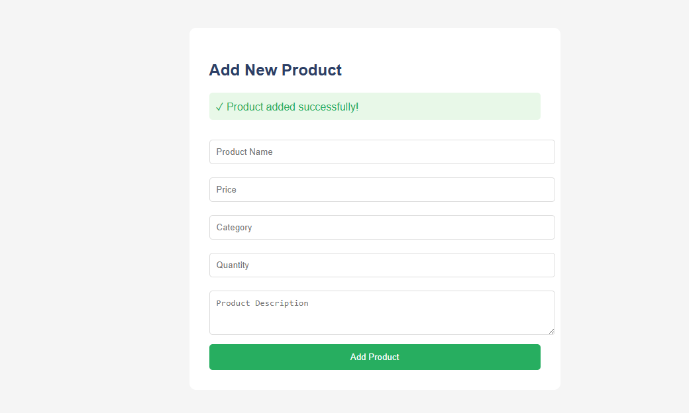
Fig 3a shows the CREATE operation where a new product is added to the database. The form collects product name, price, category, quantity, and description. Upon submission, an INSERT SQL query runs and a success message confirms the product was added.
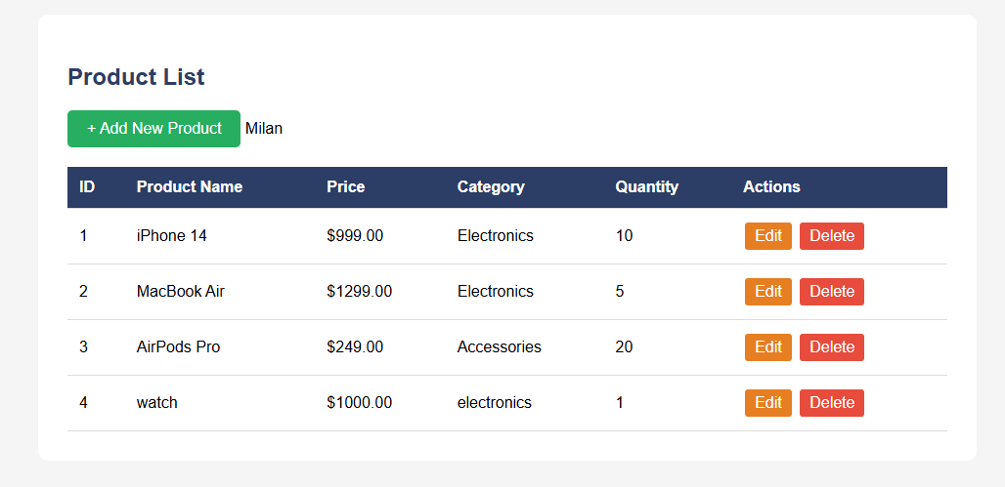
Fig 3b shows the READ operation displaying all products from the database. A SELECT SQL query retrieves all records and displays them in an HTML table with columns for ID, product name, price, category, quantity, and action buttons for Edit and Delete.

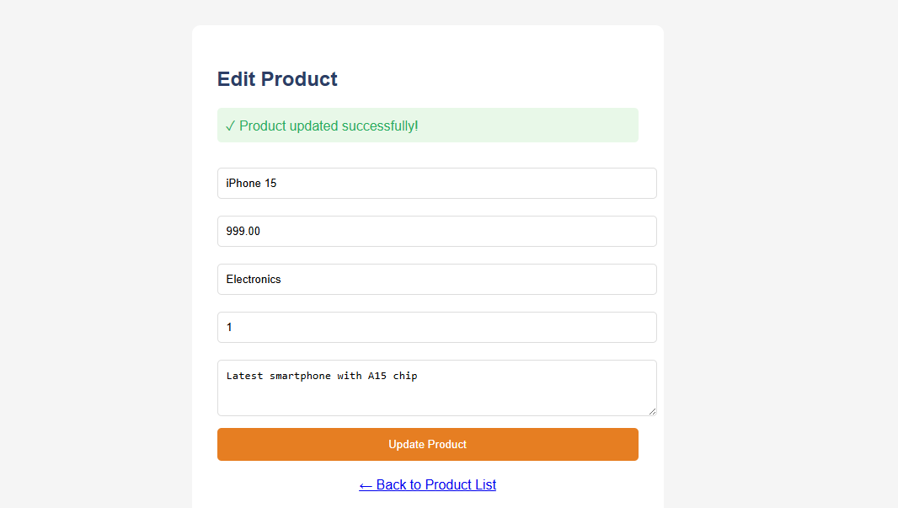
Fig 3c shows the UPDATE operation where existing product details are modified. The form loads current product data, and upon submission, an UPDATE SQL query modifies the record. A success message confirms the changes.
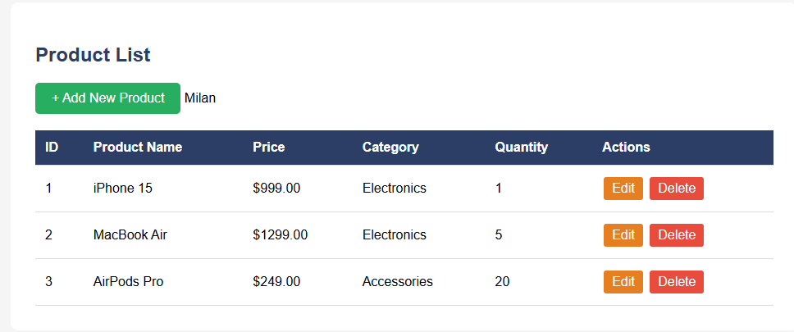
Fig 3d shows the DELETE operation where a product is removed from the database. When the Delete button is clicked, a confirmation dialog appears, then a DELETE SQL query removes the record from the products table. The product no longer appears in the product list.

Connecting PHP to Database
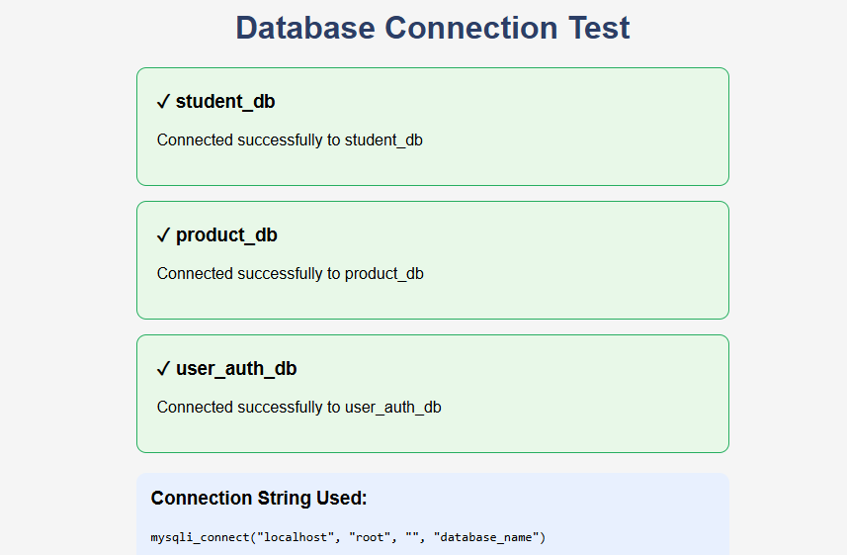
Fig 4 tests all three database connections (student_db, product_db, user_auth_db)simultaneously. Each connection uses the same mysqli_connect() function with different database names. All connections succeeded, confirming proper database setup for the Smart E-Commerce System.

Fetching Database Records
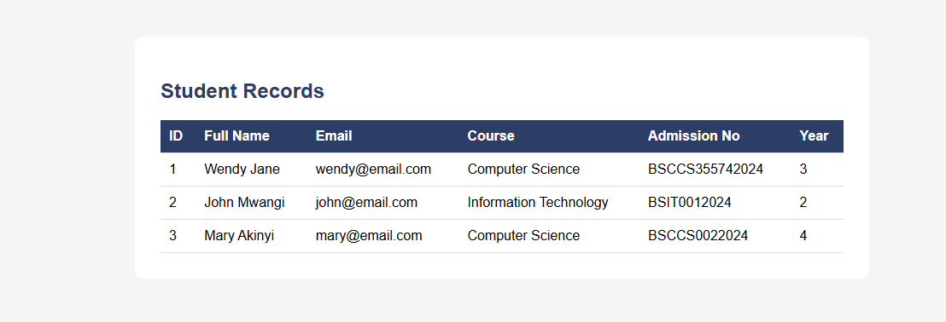
Fig 6 demonstrates fetching records from the students table using mysqli_query($conn, "SELECT * FROM students"). The while loop with mysqli_fetch_assoc($result) retrieves each row as an associative array, displaying student details including full_name, email, course, admission_number, and year_of_study.

Student reflection
Databases provide persistent storage for web applications through structured tables and relationships. CRUD operations represent Create, Read, Update, and Delete - the four basic functions of persistent data management. A products table was created with id, product_name, price, category, quantity, and description fields. SQL queries were written to insert new products, select all products for display, update existing product details, and delete products from inventory. phpMyAdmin interface was used to manage databases visually. Connection between PHP and MySQL was established using mysqli_connect() function with parameters for host, username, password, and database name. The mysqli_fetch_assoc() function retrieves records as associative arrays. A complete product management system allows administrators to add, view, edit, and remove products. These database concepts form the foundation of data-driven e-commerce applications

